Spring MVC CRUD XML Based:

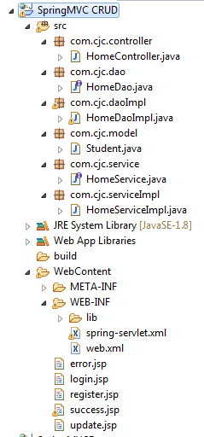

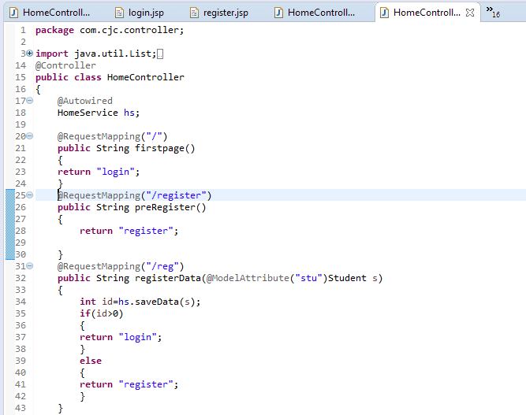

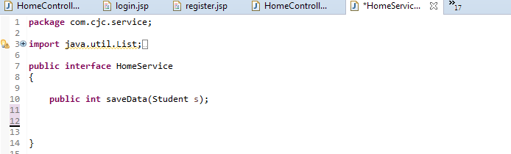

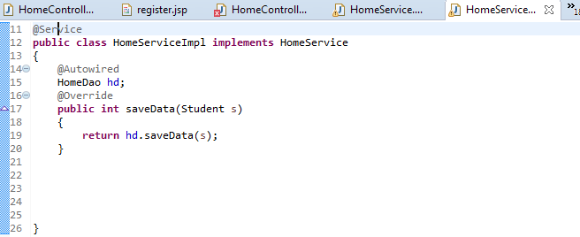

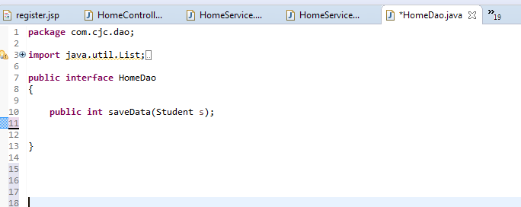

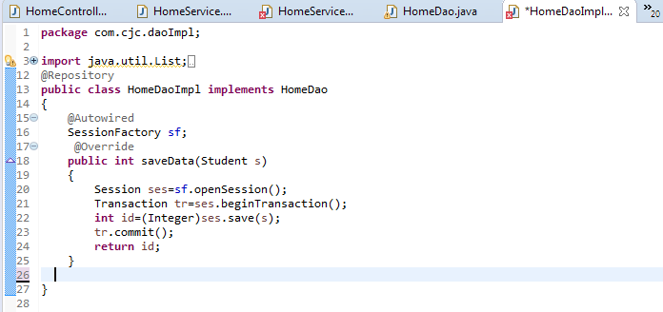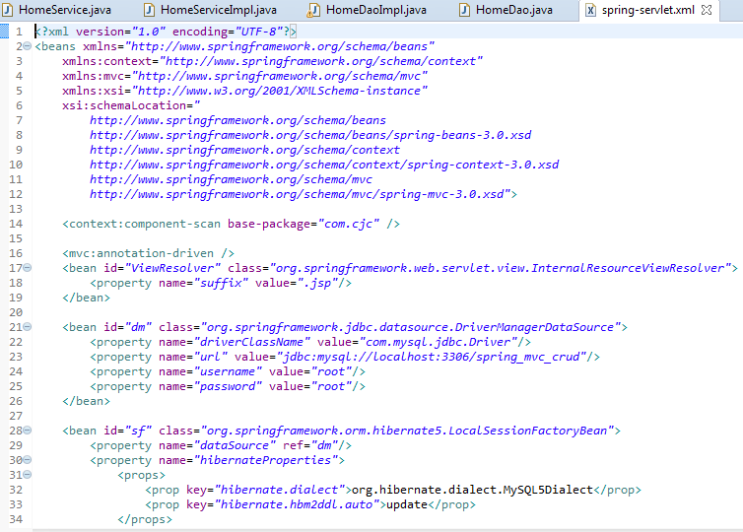

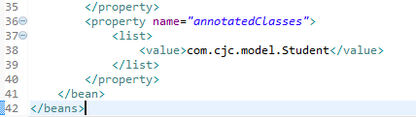

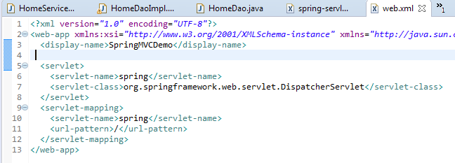

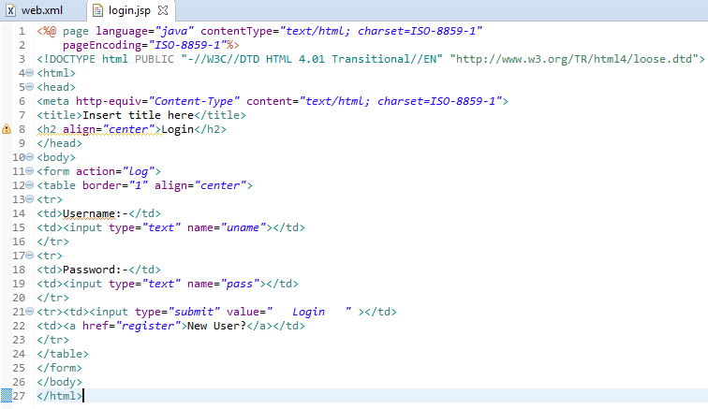

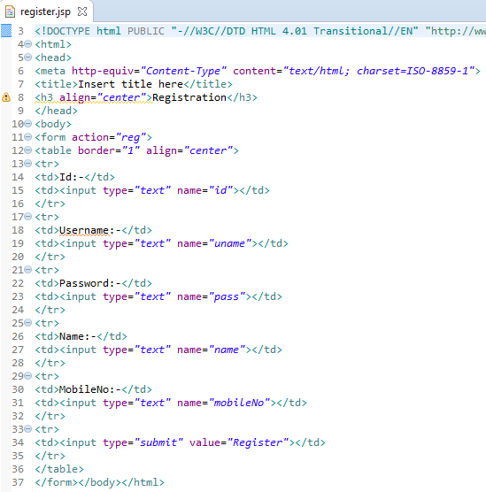

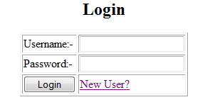

After clicking on New user link register.jsp page will open

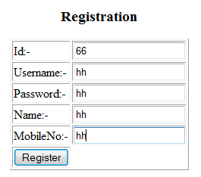

After click on register button all data of register form will stored in data base by backend program and login page will open for login.

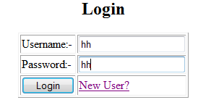

Spring-servlet.xml file

<?xml version=*"1.0"* encoding=*"UTF-8"*?>

<beans xmlns=*"http://www.springframework.org/schema/beans"*

xmlns:context=*"http://www.springframework.org/schema/context"*

xmlns:mvc=*"http://www.springframework.org/schema/mvc"*

xmlns:xsi=*"http://www.w3.org/2001/XMLSchema-instance"*

xsi:schemaLocation=*"*

*http://www.springframework.org/schema/beans*

*http://www.springframework.org/schema/beans/spring-beans-3.0.xsd*

*http://www.springframework.org/schema/context*

*http://www.springframework.org/schema/context/spring-context-3.0.xsd*

*http://www.springframework.org/schema/mvc*

*http://www.springframework.org/schema/mvc/spring-mvc-3.0.xsd"*>

<context:component-scan base-package=*"com.cjc"* />

<mvc:annotation-driven />

<bean id=*"ViewResolver"* class=*"org.springframework.web.servlet.view.InternalResourceViewResolver"*>

<property name=*"suffix"* value=*".jsp"*/>

</bean>

<bean id=*"dm"* class=*"org.springframework.jdbc.datasource.DriverManagerDataSource"*>

<property name=*"driverClassName"* value=*"com.mysql.jdbc.Driver"*/>

<property name=*"url"* value=*"jdbc:mysql://localhost:3306/spring_mvc_crud"*/>

<property name=*"username"* value=*"root"*/>

<property name=*"password"* value=*"root"*/>

</bean>

<bean id=*"sf"* class=*"org.springframework.orm.hibernate5.LocalSessionFactoryBean"*>

<property name=*"dataSource"* ref=*"dm"*/>

<property name=*"hibernateProperties"*>

<props>

<prop key=*"hibernate.dialect"*>org.hibernate.dialect.MySQL5Dialect</prop>

<prop key=*"hibernate.hbm2ddl.auto"*>update</prop>

</props>

</property>

<property name=*"annotatedClasses"*>

<list>

<value>com.cjc.model.Student</value>

</list>

</property>

</bean>

</beans>